How to create data flows

1. Create resource group and data factory and storage accounts and upload file
2. Then go to data factory-> go to authors->go to data flows

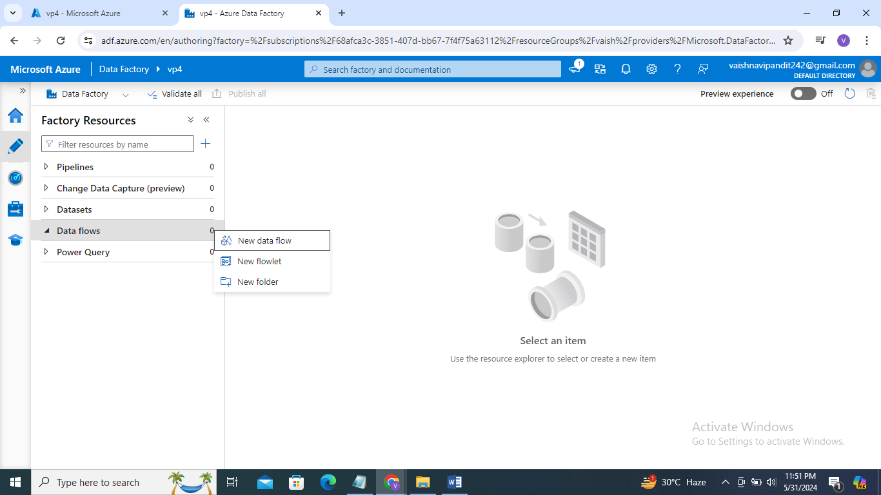

1. Enable the data flow debug on top

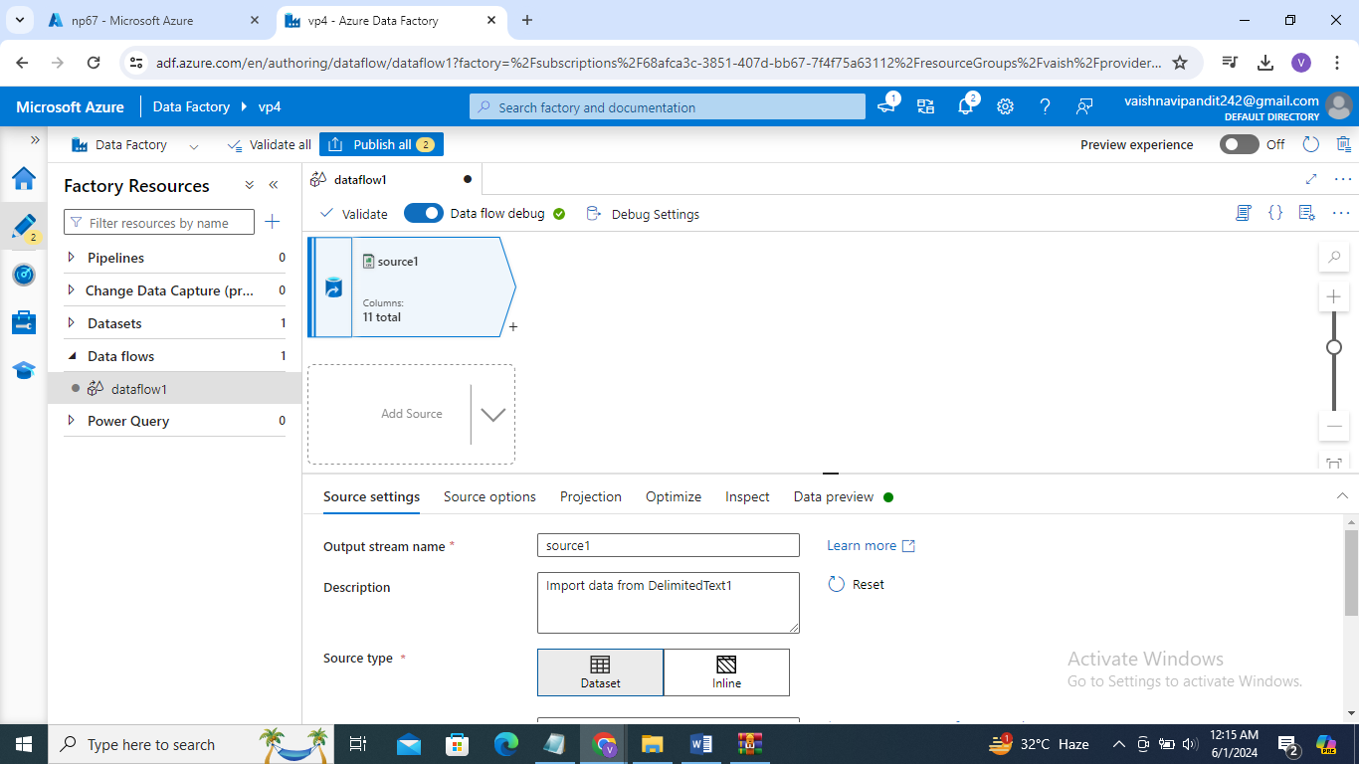

1. Go to add source ->source settings->add dataset/or create on the file that uploaded in adls

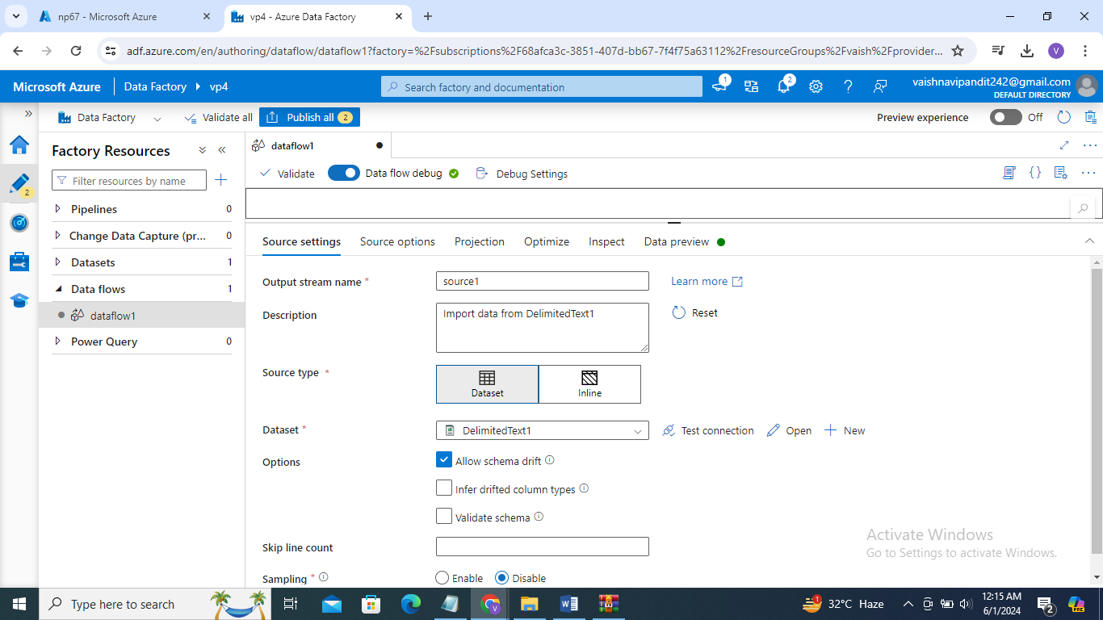

1. Go to data preview

You will find the data you uploaded there

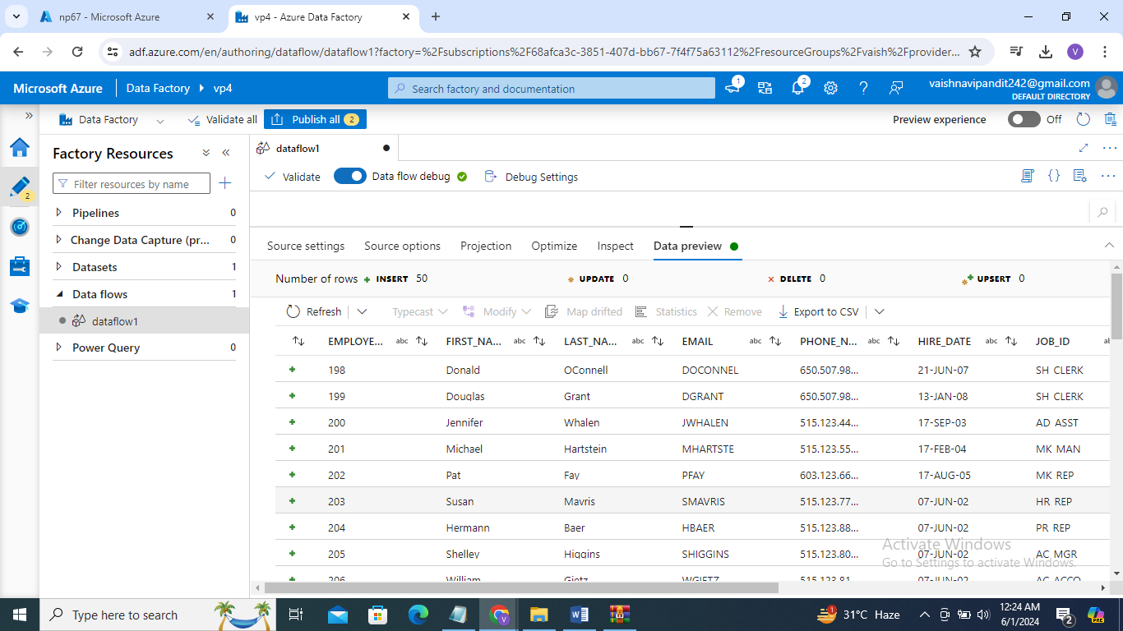

1. Go to projection->you can change datatype of the column there

